Masterpiece
Project
Coding Academy by Orange
*Printfiy*
Ashraf Shwayat
4/4/2023

Table of content:

● INTRODUCTION PURPOSE.
● INTENDED AUDIENCE AND PERTINENT SECTIONS.
● PROJECT SCOPE.
● TECHNOLOGIES.
● REFERENCES
● DESCRIPTION
● OPERATING ENVIRONMENT
● FEATURES
● DOCUMENTATION
● FLOW CHART DIGRAM
● DATABASE SCHEMA

INTRODUCTION PURPOSE
• Reduce customer time and effort.
• Reducing the cost to the customer.

INTENDED AUDIENCE AND PERTINENT SECTIONS.
Lovers of unique t-shirts who want to buy distinctive designs for themselves or as gifts for their friends.

PROJECT SCOPE
● Product catalog: The website will offer a catalog of pre-designed shirts that customers can browse and order. The catalog will include different categories of designs, such as sports, music …..

● Allows the user to search for the product easily
● The customer can communicate with us by sending a message via the contact us page easily and payment is made upon receipt in the event of the completion of the purchase process.
● Customization options: The website will offer various customization options such as the type of shirt, size, color, and print location. Customers will be able to choose from a variety of fonts, colors, and graphic elements to create their designs.

TECHNOLOGIES:
● HTML.
● CSS.
● JS.
● ASP.NET Framework.
● BOOTSTRAP
● SQL database.

SKILLS USED:
● Search skills.
● UX / UI.
● Time management.
● Visual Identity.
● Design Thinking.
● Communication Skills.

REFERENCES:
● HTML : https://developer.mozilla.org/en-US/docs/Web/HTML
● JS : https://developer.mozilla.org/en-US/docs/Web/JavaScript
● CSS : https://developer.mozilla.org/en-US/docs/Web/CSS
● SQL : https://www.w3schools.com/
● ASP.NET MVC 5 : https://learn.microsoft.com/en-us/aspnet/mvc/

DESCRIPTION
PRODUCT PERSPECTIVE
● Users are offered different roles to use the app correctly Perspective, as a user who wants to complete the purchase, he must log in, and as a user who browses and wants to buy later, he can not register and the basket is saved so that he can return to it easily.
● Also, from a managerial perspective to adjust and control Purchasing process, purchasing management and users.
● User (visitors)
The user can browse the website and search for the product
Wanted and bough.
● Admin
Administrative dashboard gives access to admins. first must login
Delete/Edit/Add/ User
Delete/Edit/Add/ Category
Delete/Edit/Add/ Products
Delete/Edit/Add/ Color and Size
Delete/View/Approvement Comment
View/Approvement Order

OPERATING ENVIRONMENT
Printfiy website and Dashboard is designed to run on all modern browsers Microsoft Edge, Google Chrome, Mozilla Firefox, Safari, Opera with an active internet connection.

FEATURES
❖ Public site

■ Login Page: Users must login using their email and password to access the public site.
■ Home page: During this page, the focus has been on shortening time and attracting the visitor's attention to make the purchase process easier, thus saving time and effort.
■ Profile Screen shows the account information and all purchase added by the user. From this screen the user can view and delete their order, edit account information, logout.

❖ Web Dashboard:

■ Login Page Admin must login using their email and password to access the administrative dashboard.
■ Dashboard Page: Adding/ Deleting Categories and Products at the top of this page.
■ Deleting Users using the public site can be deleted from this page by admin.
■ Viewing Order All orders by all users are shown in order to be monitored and controlled by admin.

❖ Projects Features:

■ The website implements SEO.
■ The website is fully responsive.
■ The website considers UX/UI design principles.
■ The website considers security by hashing strong passwords and
activating the authorization demanding the user’s role.

DOCUMENTATION:
All project files have been uploaded to GitHub and made available to all in order to share knowledge.
GitHub HTTPS : 01-Ashrafshwayat/MasterPieceProject (github.com)

FLOW CHART DIAGRAM:

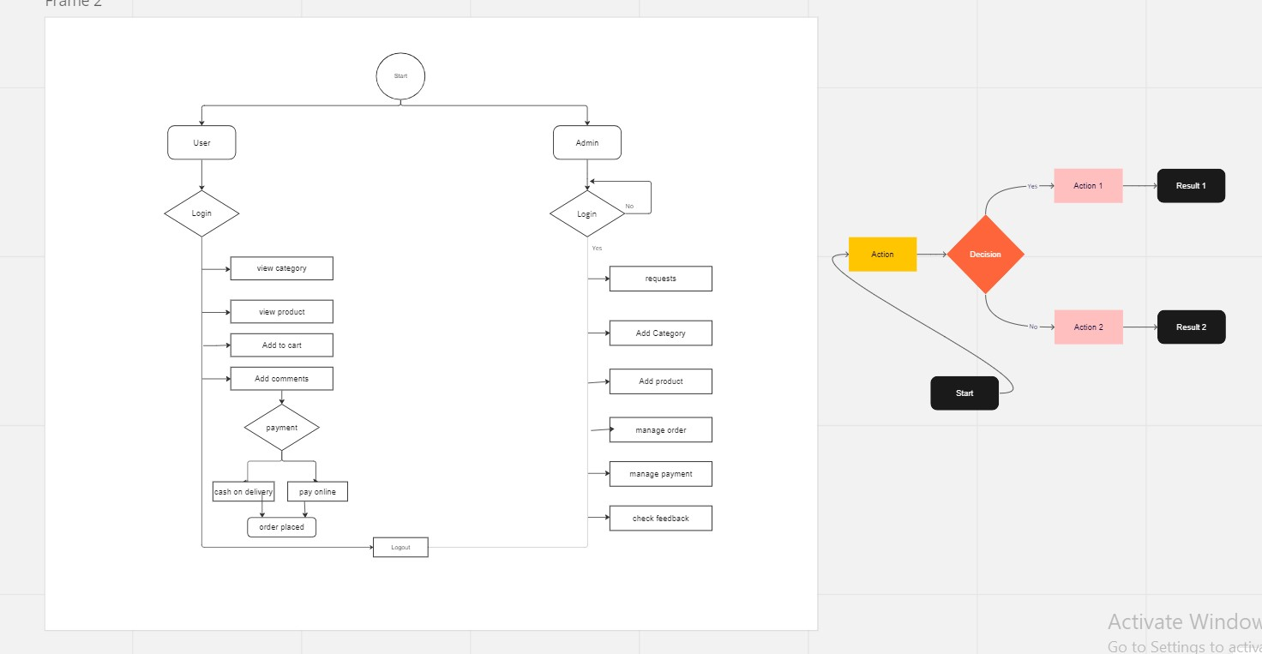

DATABASE SCHEMA:

